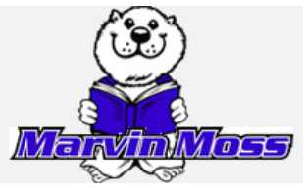
Marvin Moss Elementary School
Progressive Discipline Plan
2025-2026
The following Discipline Plan was written to adhere to guidelines set forth by NRS 392.4644. It was developed with the required stakeholders including administration, staff, parents and students of Marvin Moss Elementary.

Marvin Moss’ Vision is: We, the community of Marvin Moss, set high expectations for academic excellence, while promoting social and emotional well-being for all students. School and classroom discipline focus on consistency and positive consequences. Teachers are requested to develop a management plan annually and submit it to the principal at the beginning of each school year. All teachers have individual classroom management plans that are explained to parents at Moss Parent Nights, communicated through a classroom handbook, and posted in individual classrooms. The PBS Team developed the Moss Pledge and a school-wide matrix of behavior expectations for each area of the school campus. Students are rewarded individually with Marmot Moolah for following the Marvin Moss Pledge, and students earn Marmot Moolah for demonstrating positive academic and social behaviors. In addition, classrooms can earn Marmot Burrows for being respectful, responsible and safe, as a whole group. Marmot Chirps are given to students/parents/families for participating in school activities, initiatives, and for classroom participation. For example, when a parent/guardian signature is needed on a form, the student would earn a Chirp for returning the form with the signature.
These expectations are taught to the students during the first week of school, and they are reviewed on a consistent basis.
Our Positive Behavior Plan is based on the tenants of the Moss Pledge. The Pledge is led by a fifth-grade student and recited by the entire school daily.
The Moss Pledge:
I am an outstanding citizen.
I am Respectful,
Responsible,
And Safe.

Marvin Moss Community Procedures:
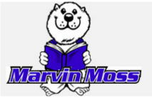 | Be Respectful | Be Responsible | Be Safe
All Settings | - Be a good listener.  - Use Kind words and actions with others.  - Treat others how you want to be treated.  - Take Turns.  - Share Material. | - Clean up.  - Treat materials properly.  - Follow directions.  - Do the right thing even when nobody is looking.  - Ask for help when needed.  - Focus on YOU. | - Keep hands, feet, objects to self.  - Use walking feet.  - Use tools to help keep a calm body.
Assembly | - Sit on pockets.  - Voices off when presenter is talking. | - Follow the quiet signal. | - Keep hands and feet to yourself.
Bathroom | - One person at a time in the restroom.  - Respect property. | - Go, flush, wash, and leave.  - Keep it clean. | - Report any problems immediately.
Bus | - Stay in seat, face forward.  - Expectations at Bus Stops are the same as when on school property. | - Keep the bus clean.  - Follow Bus Driver’s Instructions. | - Follow all safety and emergency procedures.  - Keep the aisle clear.  - Keep hands and feet to yourself.
Classroom &  Specials | - Follow the classroom rules and directions of all those in authority. | - Complete Tasks.  - Come to class on time.  - Be prepared.  - Raise hands. | - Keep hands and feet to yourself.
Exit/Enter | - Exit only at wing doors.  - Respect school property. | - Go directly to assigned areas.  - Stay in your pick -up area until time to go. | - Keep your hands and feet to yourself.
Hallway | - Walk quietly.  - Walk in a single file line with eyes forward. | - Go straight to your destination.  - Walk on the right side of the hallway. | - Keep hands and feet to yourself.
Lunchroom | - Use six- inch voices.  - Follow the quiet signal. | - Keep the lunchroom clean.  - Raise your hand for help from an adult. | - Sit on your pockets.  - Keep your hands and feet to yourself.
Technology | - All cell phones and SMART watches can be worn to and from school. During the school day, cell phones and SMART watches should be turned off and stored in the backpack. | - Treat technology/devices with care.  - Work on approved sites and stay on staff directed site when completing tasks.  - Apply critical thinking to all online sources and do not share noncredible resources such as rumors. | - Keep your passwords confidential.  - Only login as yourself.  - Report problems immediately.

When instances arise that require staff intervention, the staff member who witnesses the offense will notify the classroom teacher of the incident. The classroom teacher will utilize the classroom behavior plan. If the offense requires support from administration, information will be directed to the Principal and/or Dean of Students through a phone call or email.
Phone Call To Office | Email to Principal/Dean of Students
Violent/safety concerns/disrupting learning environment - immediate response needed.  Examples:  Fights/Physical Aggression  Threats  Destruction of school property  Yelling excessively causing disruption to learning  If staff member is not able to get to a phone to contact the office the staff member may use their Centegix Badge with a 3 button click to alert admin they need assistance. | Non Violent Acts/generally do not significantly  violate the rights of others.  Multiple Classroom Offenses  Classroom Interventions are not working  Extra Reinforcement Needed  Examples:  Not following instructions  Work Refusal  Peer Conflict  Discipline at the Door will occur for these instances

The first time a student commits a major offense, or continues to repeat disruptive behavior; any of the interventions listed below may be used.
Below is a list of interventions used at Marvin Moss by teachers and administrators. A teacher may elect to use specific intervention repeatedly if it is deemed effective with his or her students. Teachers are not required to use every option, and this list is not intended to be exhaustive in nature. There is room for both restorative practices and
other disciplinary practices.

Disciplinary Practices/Interventions at Marvin Moss
Restorative Practices/Interventions | Other Practices/Interventions
Community circles  - Morning Meetings  - Circles | Reflection/Writing exercise
Mindfulness activities  - Sanford Harmony Activities | School Beautification
Self and other awareness exercises  - Sanford Harmony | Loss of Privilege  - Study Hall
Brain/exercise breaks  - Supervised Break  - Reflection Time  - Marmot Den | Parent Conference  - Parent/Teacher/Student Conference  - Parent/Teacher/Student/Administration  - Verbal Parent Contact
Private note  - Marmot Moolah  - Student of the Week | In- School Suspension
Restorative chat  - Refocus Group  - Restorative Conferences | Out of School Suspension
Restore at the Door
Formal conferencing
Informal conferencing
- Daily Home Note
- Verbal Redirection
- Warning
Behavior/support planning
- Check in/Check out
- Monitoring/Collecting Data from Check in/Check out
- Intervention Plan
- Re-teach School Matrix
- Behavior Contract
- Behavior Intervention Plan
- MTSS Team
- Functional Behavior Assessment
- Safety Plan

Marvin Moss Elementary School
PBS Recognition System
Award Title | Who | Criteria | Award | Frequency
Verbal Praise | All Staff | Displaying one of the “Marmot Pledge” components | Immediate positive verbal praise | As often as possible at appropriate times.
Marmot Moolah | All staff | Displaying respectful, responsible and safe behavior | Immediate praise | Monthly
Marmot Burrow | All staff | The class is displaying respectful, responsible, and safe behavior. | Immediate praise | As often as possible
Marmot Chirp | All staff | Parent participation in a variety of forms | Immediately | As often as possible

Self Managers of Marvin Moss

Mission Statement
We, the Self - Managers of Marvin Moss, are committed to fostering leadership in every student by striving to be trustworthy, kind, and caring. We are determined to be helpful.

At Marvin Moss Elementary, our Self Managers represent the heart of Student Voice. Their purpose is to model leadership, integrity, and responsibility throughout the school community. Self-Managers help create a positive and inclusive environment by demonstrating what it means to be respectful, kind, and helpful. Through their actions and ideas, they help shape the culture of our school.

Playground Expectations:
We Are Respectful | We Are  Responsible | We Are  Safe
Be a good sport.  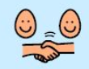 | Keep personal belongings at home.  (toys, bats, footballs)  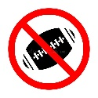 | Ask permission to leave the school playground. Play in the designated areas.  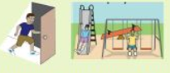
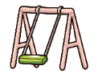  Take 20 swings when students are waiting for a swing. | Respond to time cues.  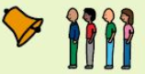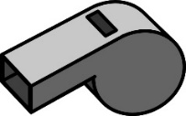  IE: Bell means time to line up | 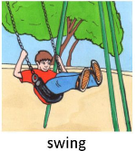  Swing back and forth on the swings sitting on our pockets.
Include others and ask others to play.  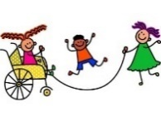 | Take pride and care on our school property.  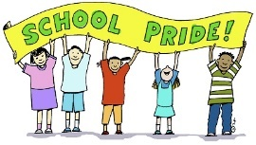 | 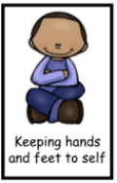  Play games that keep our hands/feet to self.
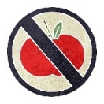  Eat food in the cafeteria or classroom. |   Safe Tagging - Light two finger touch, like butterfly wings, on the shoulder, upper arm or upper back. | 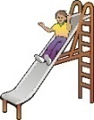  Go down the slide one at a time. Feet first and on your pockets.

WCSD’s Behavior Matrix
Revised 2023
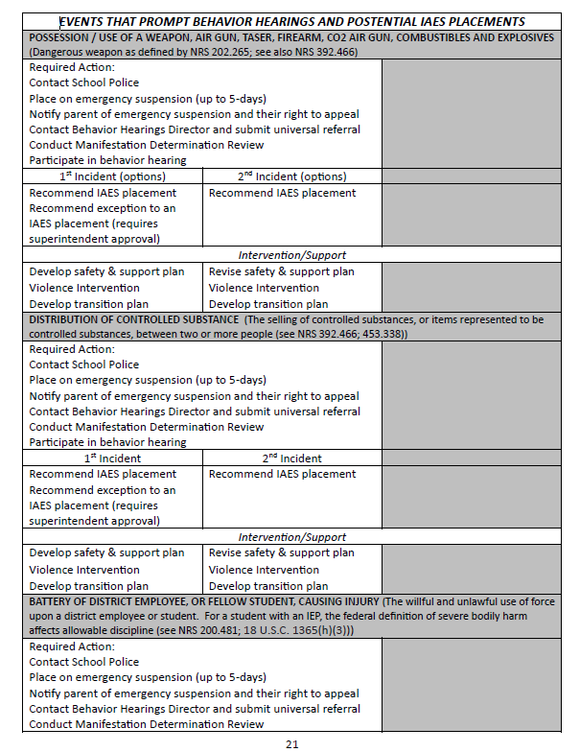

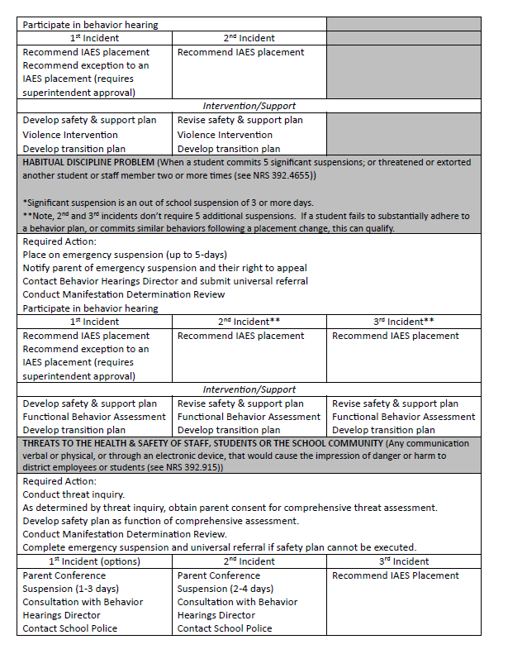

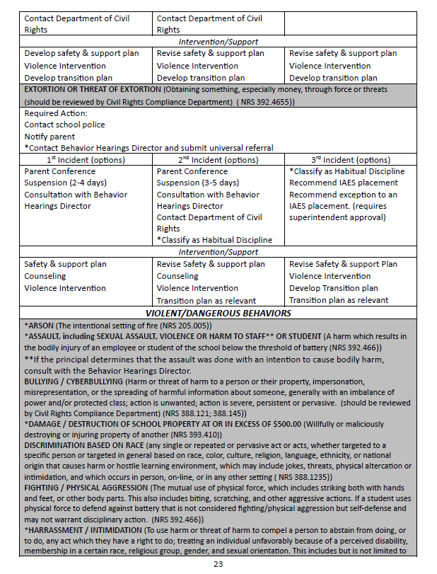

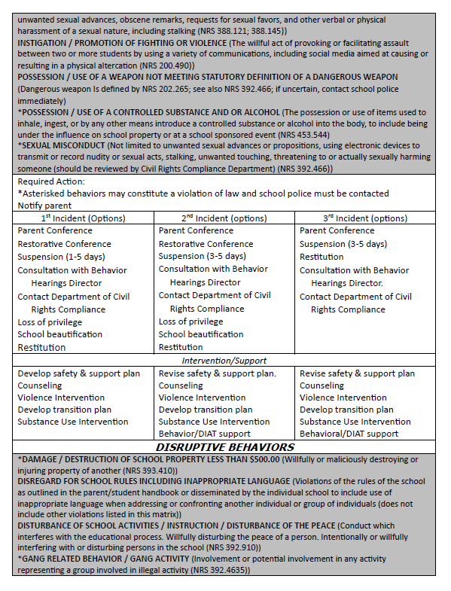

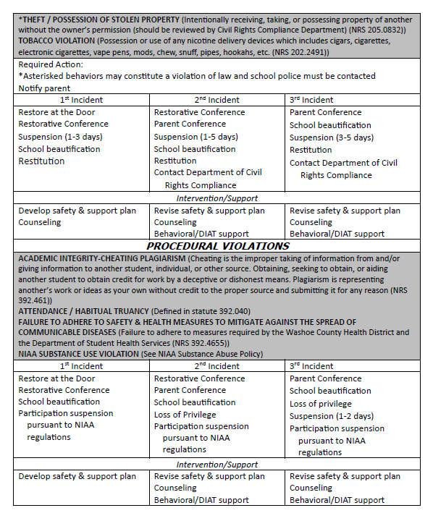

**Administration reserves the right to implement alternative consequences, as needed.

